**LECTURE 2 – Versions used in this Course**

* These are the following versions used in this tutorial:
* [**create-react-app@1.5.2**](mailto:create-react-app@1.5.2)
* [**node@8.2.1**](mailto:node@8.2.1)
* [**npm@5.3.0**](mailto:npm@5.3.0)
* [**react@16.3.2**](mailto:react@16.3.2)
* [**jest@22.4.3**](mailto:jest@22.4.3)
* [**enzyme@3.3.0**](mailto:enzyme@3.3.0)
* [**Enzyme-adapter-react-16@1.1.1**](mailto:Enzyme-adapter-react-16@1.1.1)
* [**redux@4.0.0**](mailto:redux@4.0.0)
* [**React-redux@5.0.7**](mailto:React-redux@5.0.7)
* [**Redux-thunk@2.2.0**](mailto:Redux-thunk@2.2.0)
* [**axios@0.18.0**](mailto:axios@0.18.0)
* [**moxios@0.4.0**](mailto:moxios@0.4.0)

**LECTURE 3 – TDD: What and Why**

* In this lecture we will be implementing **TDD** which means that we will be writing the tests before we write the code.
* You write a shell version of the code, enough to call it from the test, then you write a test that fails (We do this to make sure the test fails before they succeed), then you write the code that makes the tests past.
* TDD helps you write better code.
* The code is better organized.
* The code is more test-able.
* There are fewer bugs.
* We will have **Regression Testing** built-in, meaning that all the tests that we’ve ever written will get run every time you make a change.

**LECTURE 4 – create-react-app**

* We will now install the **jest** and **babel-jest** libraries by using **create-react-app**. The create-react-app library creates these 2 libraries automatically.
* If you don’t already have the **create-react-app** library installed then do that first.
* Open VS Code and open a terminal.
* In the terminal create your React App by typing **create-react-app demo**.

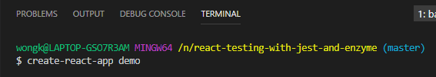

**LECTURE 5 – Setting up Jest without create-react-app**

**LECTURE 6 – Demo of Jest Watch Mode**

* Open your project at the root (demo folder) in VS Code.
* We are going to test Jest.
* In a terminal type **npm test**.
* A Jest Test will be executed.

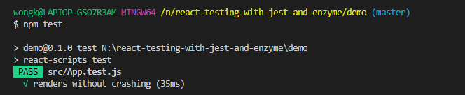

* These Jest tests will be run each time you save the file.
* Go to **App.js** and make the following changes.

import React, { Component } from 'react';

import logo from './logo.svg';

import './App.css';

class App extends Component {

render() {

return (

<div className="App">

<h1>Hello World</h1>

<header className="App-header">

<img src={logo} className="App-logo" alt="logo" />

<p>

Edit <code>src/App.js</code> and save to reload.

</p>

<a

className="App-link"

href="https://reactjs.org"

target="_blank"

rel="noopener noreferrer"

>

Learn React

</a>

</header>

</div>

);

}

}

export default App;

* When you save the changes a Jest Test will automatically be run.

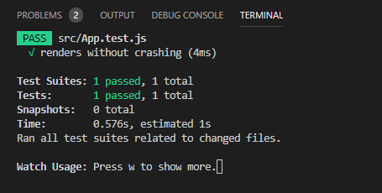

**LECTURE 7 – More about Jest Watch Mode, Test Files and Tests**

* Jest Watch Mode only watches for changes since your last commit.
* Fas
* Fsad
* Fa
* Sdf
* Asdf
* Asdf
* Asf
* Asdf
* Asf
* As
* Df
* Ads
* Fas
* Fsad
* Fa
* sdf
* Asdf
* Asdf
* Asf
* Asdf
* Asf
* As
* Df
* Ads
* Fas
* Fsad
* Fa
* sdf
* Asdf
* Asdf
* Asf
* Asdf
* Asf
* As
* Df
* Ads
* Fas
* Fsad
* Fa
* sdf
* Asdf
* Asdf
* Asf
* Asdf
* Asf
* As
* Df
* Ads
* Fas
* Fsad
* Fa
* sdf
* Asdf
* Asdf
* Asf
* Asdf
* Asf
* As
* Df
* Ads
* Fas
* Fsad
* Fa
* sdf
* Asdf
* Asdf
* Asf
* Asdf
* Asf
* As
* Df
* Ads
* Fas
* Fsad
* Fa
* sdf
* Asdf
* Asdf
* Asf
* Asdf
* Asf
* As
* Df
* Ads
* Fas
* Fsad
* Fa
* sdf
* Asdf
* Asdf
* Asf
* Asdf
* Asf
* As
* Df
* Ads
* Fas
* Fsad
* Fa
* sdf
* Asdf
* Asdf
* Asf
* Asdf
* Asf
* As
* Df
* Ads
* Fas
* Fsad
* Fa
* sdf
* Asdf
* Asdf
* Asf
* Asdf
* Asf
* As
* Df
* Ads
* Fas
* Fsad
* Fa
* sdf
* Asdf
* Asdf
* Asf
* Asdf
* Asf
* As
* Df
* Ads
* Fas
* Fsad
* Fa
* sdf
* Asdf
* Asdf
* Asf
* Asdf
* Asf
* As
* Df
* Ads
* Fas
* Fsad
* Fa
* sdf
* Asdf
* Asdf
* Asf
* Asdf
* Asf
* As
* Df
* Ads
* Fas
* Fsad
* Fa
* sdf
* Asdf
* Asdf
* Asf
* Asdf
* Asf
* As
* Df
* Ads
* Fas
* Fsad
* Fa
* sdf